I guess one of the ways to think about this problem is to use real numbers. The problem with that though is that it is counterintuitive in how the number line is laid out. Traditionally numbers on a line go from left to right, negative to positive. I am not the SAT guru like you Paul but the lack of information about the number line tells me that something is up. You could assign number values like x = 3 and y = -1 and have the equations read like x = 3; x + y = 3 + (-1) = 2; (x + y)/2 = (3 + -1)/2 = 1. From that you can follow the pattern and find out that y is placed at E.

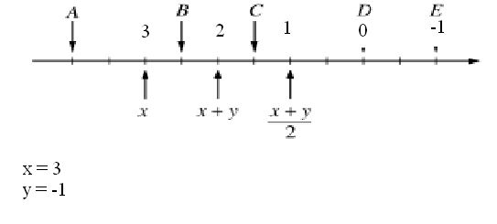

Another, and probably easier way to look at it is to see that the equation (x +y)/2 is an average of x and y. In order to find an answer, you need to relate the position of the average equation to the given point x. Since both x and answer E are an equal distance from this equation so it can be extrapolated that letter E is equal to y.

