Solution for SAT Problems #20

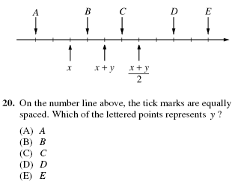

This is a difficult problem, but one where Plugging In Numbers can help. But before you try that (you’ll find that guessing numbers at this first stage is a little haphazard), see if you can simplify the problem first.

Remember the Midpoint Formula? It just says that you can find the midpoint of any two points by adding them together and then dividing by 2. The Average Formula works similarly. So for this problem, if you added the points x and (x+y)/2, then divided by two, you’d get the midpoint, or x + y. To put this algebraically:

x + (x+y)/2 = x + y
2

Cross-multiplying then multiplying everything by 2, we get

x + (x+y)/2 = 2(x + y)

then

2x + (x+y) = 4(x + y)

Now we can simply distribute and combine like terms to get a more reasonable equation:

3x + y = 4x + 4y
-x = 3y

Now we can Plug In Numbers. Let’s say x = 3 and y = -1. Putting these on the graph shows that the values of the x, x + y, and (x+y)/2, respectively, are 3, 2 and 1. This jives with our graph (note that the number line gets smaller from left to right, the opposite of our typical number line). All we have to do now is figure out which tick mark represents y, or -1. The answer is “E”.

